[Digital System Design](https://digitalsystemdesign.in/)

We gather, we share, you learn.......

Top of Form

Bottom of Form

Top of Form

Bottom of Form

Implementing Large Multiplier Using Smaller ones

By [DR. SHIRSHENDU ROY](https://digitalsystemdesign.in/author/shirshenduroy88/)/ 18th June 2019 / [Uncategorized](https://digitalsystemdesign.in/category/uncategorized/)

Like Booth’s multiplication algorithm another method reduction of partial products is implementing higher multipliers by smaller ones. The larger multiplier blocks can be realized using smaller multiplier blocks. A  multiplier can be realized using four  multiplier blocks. This is based on the following equation

where  is the most significant halve of A,  is the most significant halve of X,  is the least significant halve of A and  is the least significant halve of X.

The partial products from the smaller multiplier blocks should be correctly arranged and accumulated by fast multi-operand adders. A scheme of implementing a 8 bit multiplier using four  multipliers is shown below in Figure 1.

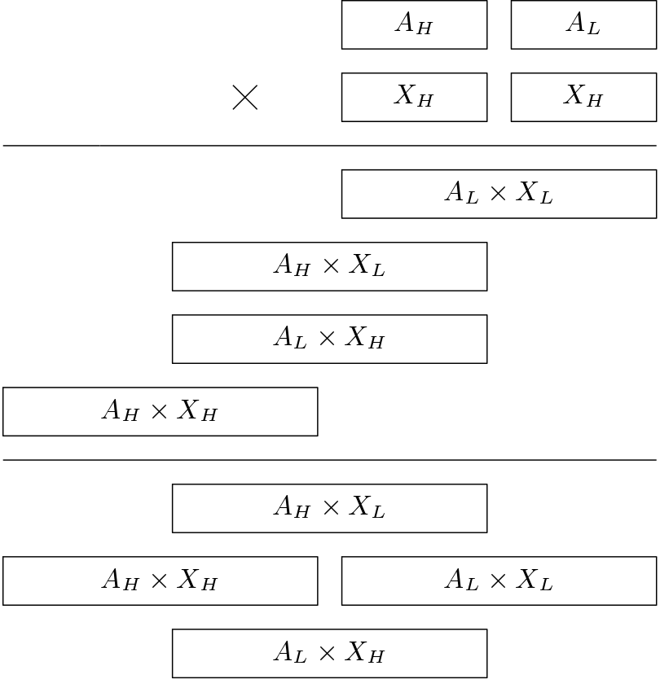

Figure 1: Implementation of 8-bit multiplier using two 4-bit multipliers

Queries? Email at [*info@digitalsystemdesign.in*](mailto:info@digitalsystemdesign.in)

Das Vila, 17, Rajani Kanta Chowdhury Lane, Shibpur, Howrah-711103

Copyright © 2023 [Digital System Design](https://digitalsystemdesign.in/)